

Find us at:

[Description: Linked-In-icon](http://www.linkedin.com/home?trk=nav_responsive_tab_home) [Description: FaceBook-icon](https://www.facebook.com/pages/Langton-Capital/259278650765476) [Description: Twitter-icon](https://twitter.com/)

*Recent News Here:*

* [*Today's* *email*](http://www.langtoncapital.co.uk/)
* [*Recent e**mails*](http://www.langtoncapital.co.uk/upcoming-results-events/recent-leisure-updates)
* [*A day in the life...*](http://www.langtoncapital.co.uk/a-day-in-the-life)
* [*Who we are, what we do...*](http://www.langtoncapital.co.uk/who-we-are-what-we-do)
* [*Upcoming news-flow*](http://www.langtoncapital.co.uk/upcoming-results-events)
* [*Recent company updates*](http://www.langtoncapital.co.uk/upcoming-results-events/company-updates)
* [*Thematic pieces*](http://www.langtoncapital.co.uk/upcoming-results-events/home-2)
* [*LinkedIn profile*](http://www.linkedin.com/profile/view?id=85312462&authType=name&authToken=qoBn&locale=en_US&pvs=pp&trk=ppro_viewmore)

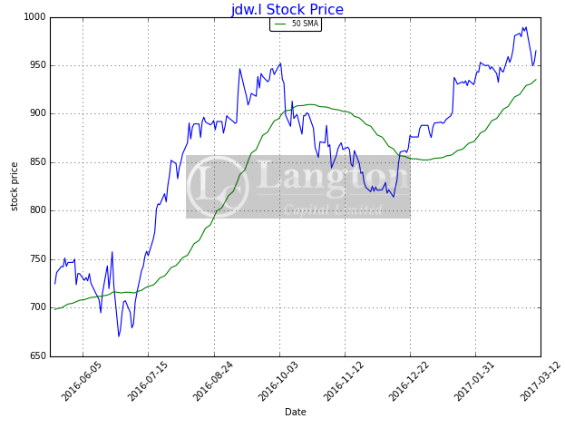

Market Cap: £1,067m

12m range 663p 989p

10 Mar 2017

**JD WETHERSPOON (JDW): 957p**

**H1 Numbers: 12wks to 15 Jan 2017:**

*Group says margins currently up but ‘the company remains cautious about the second half…’*

|  |  |  |  |  |  |
| --- | --- | --- | --- | --- | --- |
| **Year to end-July** | **PBT**  **(£m)** | **EPS* (p)** | **PER**  **(x)** | **DPS (p)** | **Yield**  **(%)** |
| 2016 (A) | 76.0 | 48.3 | 19.8 | 12.0 | 1.3 |
| 2017 (E) | 84.5 | 55.0 | 17.4 | 12.0 | 1.3 |
| 2018 (E) | 86.0 | 57.0 | 16.8 | 12.0 | 1.3 |

*Normalised, Source: Company & Broker Estimates

## H1 Numbers for the 12wks to 15 Jan 2017:

JD Wetherspoon has this morning reported H1 numbers for the period comprising the 13wks to 15 Jan 2017 and our comments thereon are set out below:

### Headline Numbers:

* JD Wetherspoon updates on trading saying that LfL sales in the first 12wks of Q2 rose by 3.2%
* Total sales rose by 0.7%, the lower number impacted by the number of pub disposals during the period. Recent sales trends are shown below:

**Tab.1. Recent Sales Trends:**

|  |  |
| --- | --- |
| **Financial Period** | **LfL Sales**  **(%)** |
| Full year 2008/09 | +1.2 |
| Full year 2009/10 | +0.1 |
| Full year 2010/11 | +2.1 |
| Full year 2011/12 | +3.2 |
| Full year 2012/13 | +5.3 |
| Full year 2013/14 | +5.5 |
| Full year 2014/15 | +3.3 |
| Q1 | +2.4 |
| Q2 | +3.3 |
| H1 2015/16 | +2.9 |
| Q3 | +3.8 |
| Q4 | +4.0 |
| Full year 2015/16 | +3.4 |
| Q1 2016/17 | +3.5 |
| Q2 2016/17 | +3.2 |

Source: Company Reports

### More on Trading:

* JDW reports ‘we expect the operating margin (before any exceptional items) for the half year ending 22 January 2017 to be around 8.0%, 1.7% higher than the same period last year.’
* Chairman JDW criticises economic commentators as having ‘catastrophically poor judgement’
* He says ‘the Company anticipates significantly higher costs in the second half of the financial year. On an annualised basis, these are expected to rise by about 4% for wages, by £7m for business rates and by £2m for the Apprenticeship Levy, in addition to cost increases at around the level of inflation in other areas.’
* He says ‘as previously announced, the Company intends to increase the level of capital investment in existing pubs from £34m in 2015/6 to around £60m in the current year.’
* Mr Martin concludes ‘in view of these additional costs and our expectation that like-for-like sales will be lower in the next six months’
* He says ‘the Company remains cautious about the second half of the year’ but adds ‘nevertheless, as a result of modestly better-than-expected year-to-date sales, we currently anticipate a slightly improved trading outcome for the current financial year, compared with our expectations at the last update.’

### Balance Sheet, Debt & Outlook:

* JDW reports it has opened two new pubs since the start of the financial year
* It has sold 21.
* JDW adds ‘we intend to open 10 to 15 pubs in the current financial year.’
* Re disposals, JDW comments ‘we have now sold the majority of those pubs which had been put on the market in 2016, with a remaining small number which is either 'under offer' and going through the sales process or being marketed by our agents.’
* JDW says it ‘remains in a sound financial position.’
* It says ‘net debt at the end of this financial year is currently expected to be around £50m higher than the level at the last financial year end, partly as a result of the purchase of an increased number of freehold reversions.’

**Langton View:** JD Wetherspoon reports that the outcome for the current year should be ‘slightly improved’ versus its earlier predictions.

Margins are also higher in Q2 than they were a year ago and this should come as a relief to some.

LfL sales are currently good but will fall in Q3 and Q4. This is partly as a result of tough comps.

Overall, trading is perhaps slightly ahead of expectations but, as the group’s shares have been strong, this may not be sufficient to push them higher.

The group’s shares are trading at around 17x earnings which and look to be relatively fully-priced

|  |
| --- |
| **Contact – Mark Brumby - +44(0)20 7702 3389** |
| [mark.brumby@langtoncapital.co.uk](mailto:mark.brumby@langtoncapital.co.uk) |

*This message (and files contained herein) may contain confidential or proprietary information and is intended solely for the use of the individual or organisation to whom it is addressed.   If you are not the addressee you should not disseminate, distribute or copy this email or any part thereof.   Further, please notify the author immediately by telephone or by replying to this email and then delete all copies of the correspondence from your system.   We apologise for any inconvenience that this may have caused.   This information is a financial promotion for the purpose of the European Markets in Financial Instruments Directive (MiFID) and FSA’s Rules. It has not been prepared in accordance with the legal requirements designed to promote the independence or objectivity of investment research. This document is not based upon detailed analysis by Langton Capital of any market, issuer or security named herein and does not constitute formal research or a research recommendation, either expressly or otherwise. It is not investment advice and does not take into account the investment objectives and policies, financial position or portfolio composition of any recipient. This document should not to be relied upon as authoritative or taken in substitution for the exercise of you own commercial judgment.   Whilst Langton Capital has taken steps to control the spread of viruses on its systems, it cannot guarantee that this email and any files transmitted with it are virus free.   No liability is accepted for any errors, omissions, interceptions, corrupted email, lost communications or late delivery arising as a result of receiving this message via the Internet or for any virus that may be contained in it.   Recipients should review independently and / or obtain independent professional advice and draw their conclusions there-from should decide to undertake transactions with third parties.   Langton Capital or its employees may have positions in securities mentioned herein.   We reserve the right to monitor email messages passing through our network.   Langton Capital Limited is authorised and regulated by the Financial Conduct Authority.   Langton Capital Limited is registered in England number 07112949.*